8.6: From Eq. (8.2), and so the total momentum has magnitude

and is at an angle arctan 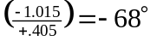, using the value of the arctangent function in the fourth quadrant 